GREG LAKE IS PLEASED TO ANNOUNCE TWO RE-RELEASE PROJECTS FOR CHRISTMAS 2015!
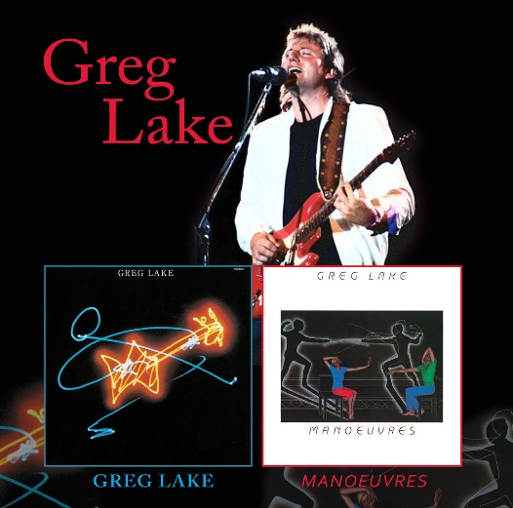
Christmas 2015 will see the release of a double CD of Greg Lake’s first self-titled solo album from 1981 and his second solo album Manoeuvres from 1983. This 2 CD set will include four bonus tracks which were previously only available on the “From the Underground Vol. 2” release, along with an extensive booklet.
This is a great and easy way to buy both of Greg Lake’s studio albums and all the rarities connected to these albums in one place. This title will be released on 27th November 2015 and can be pre-ordered from Amazon here: http://geni.us/2JSb
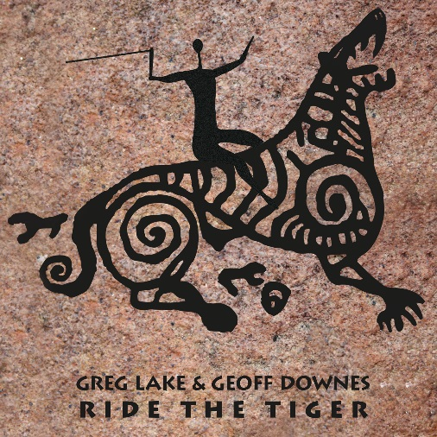
Also set for release on the same date will be Greg Lake and Geoff Downes’ Ride the Tiger project, which is a collection of six songs (plus one alternate version), recorded in late 1989 – early 1990, which have never been released together before. Four of the songs appeared on “From the Underground” and “From the Beginning: The Greg Lake Anthology” but this set includes the previously unreleased Street War and Affairs of the Heart – both of which ELP fans will recognise.
This release includes all new artwork and has the full approval of both Greg Lake and Geoff Downes.
This title will also be released on 27th November 2015 and can be pre-ordered from Amazon here: http://geni.us/1UEo

