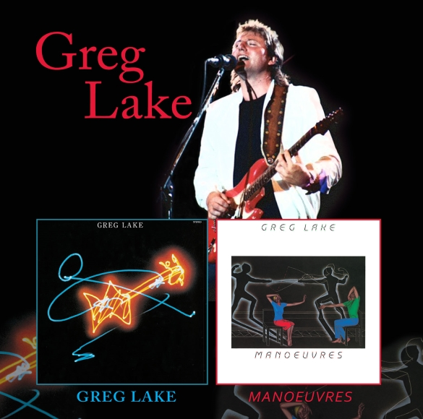

For Immediate Release

**Greg Lake Re-releases His Two Solo Albums “Greg Lake” & “Manoeuvres” on Double Disc Set, a Week After Receiving an Honourary Degree!**

London, UK - Greg Lake is the co-founder of KING CRIMSON and EMERSON LAKE AND PALMER (ELP), and wrote the hit “LUCKY MAN” and co-wrote “I BELIEVE IN FATHER CHRISTMAS”.

This 2-CD set collects together both of Lake’s two solo albums, his first self-titled album (1981) and his second album “Manoeuvres” (1983). The set includes FOUR BONUS TRACKS which have never been included on any re-issue of the albums, only on separate rarities albums.

The first album and its three bonus tracks feature all of the members of TOTO with the exception of Bobby Kimball as Lake handles all lead vocals. Both albums also feature appearances GARY MOORE on guitar.

Both CDs have received a 2015 REMASTER which has the personal approval of GREG LAKE. The booklet includes extensive liner notes. This is a great and easy way to buy both of Greg Lake’s studio albums and all the rarities connected to these albums in one place.

Track Listing:

DISC ONE: GREG LAKE

1. NUCLEAR ATTACK

2. LOVE YOU TOO MUCH

3. IT HURTS

4. BLACK AND BLUE

5. RETRIBUTION DRIVE

6. LONG GOODBYE

7. THE LIE

8. SOMEONE

9. LET ME LOVE YOU ONCE

10. FOR THOSE WHO DARE

BONUS TRACKS

11. YOU REALLY GOT A HOLD ON ME

12. YOU’RE GOOD WITH YOUR LOVE

13. COLD SIDE OF A WOMAN

DISC TWO: MANOEUVRES

1. MANOEUVRES

2. TOO YOUNG TO LOVE

3. PARALYSED

4. A WOMAN LIKE YOU

5. I DON'T WANNA LOSE YOUR LOVE TONIGHT

6. IT'S YOU, YOU GOTTA BELIEVE

7. FAMOUS LAST WORDS

8. SLAVE TO LOVE

9. HAUNTED

10. I DON'T KNOW WHY I STILL LOVE YOU

BONUS TRACK

11. HOLD ME

To purchase “Greg Lake” & “Manoeuvres” on 2-CD Set: Amazon CD: <http://geni.us/2o0W>

In other news, on January 9th Greg received an honourary degree from the Conservatorio Nicolini in Piacenza, Italy! This was the very first honourary degree for music the prestigious university has ever awarded!

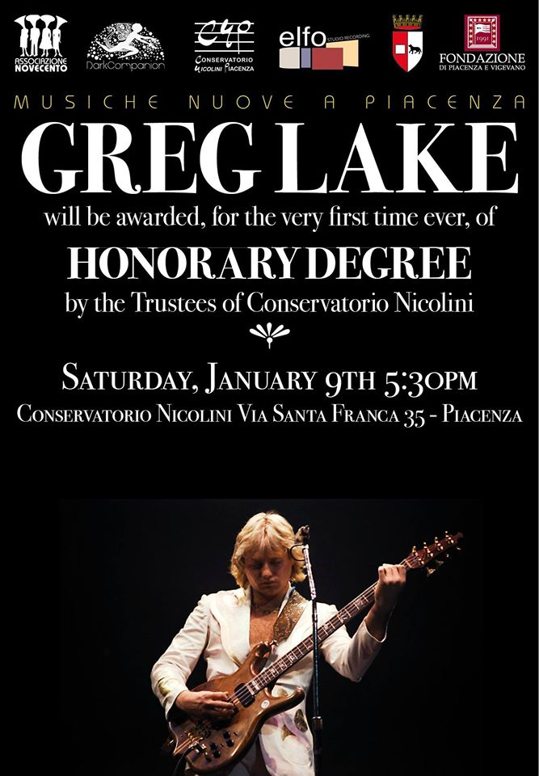

Greg Lake's official website: [www.greglake.com](http://www.greglake.com/)

Facebook: <https://www.facebook.com/Greg-Lake-118368008204116/>

Press inquiries: Glass Onyon PR, PH: [828-350-8158](tel:828-350-8158) (USA), [glassonyonpr@gmail.com](mailto:glassonyonpr@gmail.com)