For immediate release
Contact:
For booking: Paradise Artists, Jim Lenz (805) 646-8433 Jim@paradiseartists.com
For management enquiries: QEDG management qedg@live.co.uk
For press and pr information: Ellie Schwartz 1. 347.678.1760, ellies@aol.com
London, 27 January, 2010

Rock and Roll Legends Keith Emerson and Greg Lake to tour USA in an exclusive intimate evening of musical retrospective highlighting the iconic music of Emerson Lake and Palmer, the Nice and King Crimson.

The two man show with keyboard legend Keith Emerson and the famed voice and guitars of Greg Lake is an intimate “unplugged” prelude to the highly anticipated reunion of Emerson Lake and Palmer at the High Voltage Festival in July, 2010 in the UK. It is unlike any show either of the two have performed before, separately or with others.

The fabric of the show is the extraordinary music composed by Emerson and Lake throughout their careers and audiences can expect new perspectives as well as new arrangements of classic favorites as Keith and Greg relate the stories of their songs and discuss the compositions and people that influenced the celebrated music the two created with the progressive rock bands that went down in history as the super groups that began a rock and roll era: King Crimson , the Nice, and Emerson Lake and Palmer.

The show is completely new – the two have never performed together in this personal setting and audiences will be treated to an emotional perspective and a rare and personal insight into the music they love during an evening they won’t forget, in an intimate theatrical setting which far different from the theatrics of Emerson Lake and Palmer.

Special VIP ticket packages available at http://tixx1.artistarena.com/emersonlake

The tour begins in April and the following dates are already booked.
Thu Apr 1 '10 Lakewood OH Lakewood Civic Auditorium
Fri Apr 2 '10 Glenside PA Keswick Theater
Sat Apr 3 '10 Ridgefield CT Ridgefield Play House
Tue Apr 6 '10 Alexandria VA The Birchmere
Thu Apr 8 '10 New York NY Nokia TheatreTimes Square
Fri Apr 9 '10 Westbury NY Westbury Music Fair
4/10/2010 New Bedford, MA Zeiteron Performing Arts Center
Tue Apr 13 '10 Montreal QC Place des Arts
Fri Apr 16 '10 Milwaukee WI Potawatomi Casino / Northern Lights Theatre
Sat Apr 17 '10 Merrillville IN Star Plaza Theatre
Sun Apr 18 '10 Indianapolis IN Murat Theatre at the Murat Centre
4/25/2010 Los Angeles, CA Orpheum Theatre

An Intimate Evening with Keith Emerson and Greg Lake featuring the Music of Emerson Lake and Palmer, the Nice, and King Crimson is booked in the US exclusively by Paradise Artists:

California: Phone: (805) 646 – 3367 Fax: (805) 646 - 3367
New York: Phone: (212) 879-5900 Fax: (212) 879-0668

Keith Emerson and Greg Lake are managed by Stewart Young and Martin Darvill at QEDG Management, QEDG@live.co.uk

Press and tour information:
Ellie Schwartz, 1.347.678.1760
Ellies@aol.com

Attachments:
- Logo
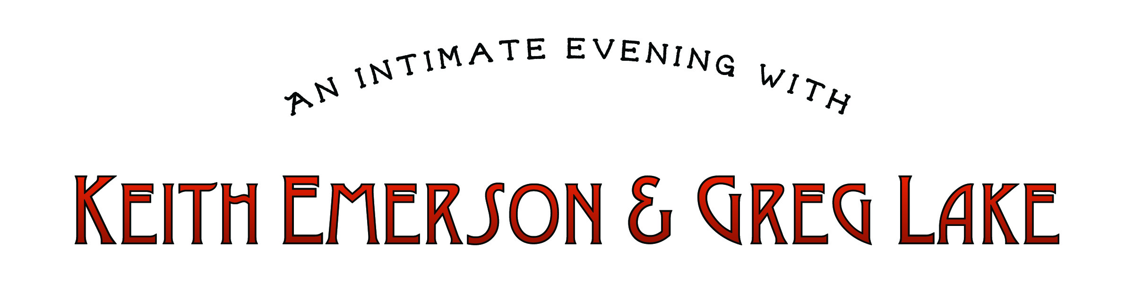
- 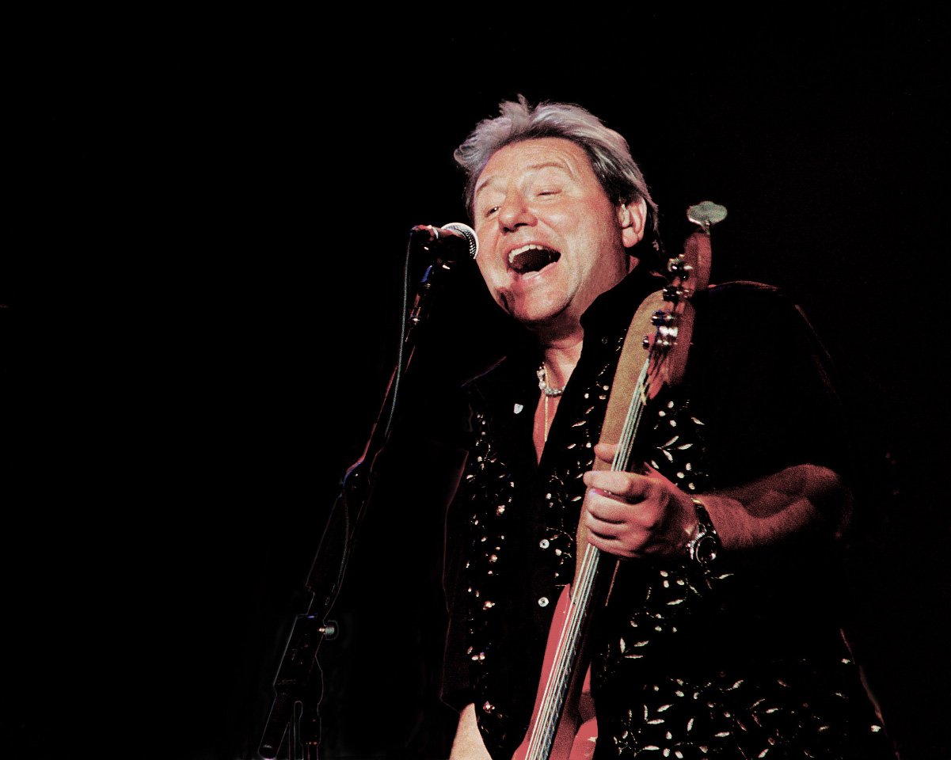 Greg Lake photographed by Marc Eisenoff
- Keith Emerson photographed by Mari Kawaguchi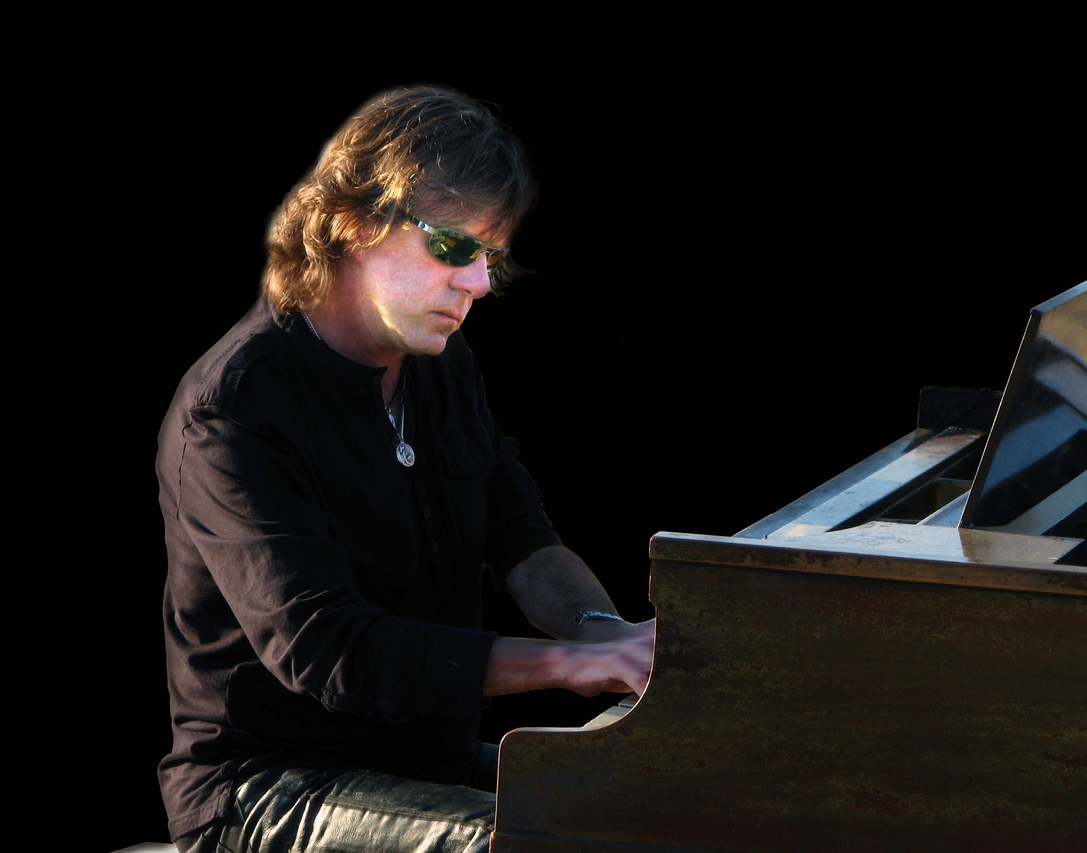
Biographies

Keith Emerson and Greg Lake formed Emerson Lake and Palmer together with drummer Carl Palmer after finding a common bond when Emerson’s band The Nice toured with Greg Lake in King Crimson. The two began writing and performing partnership that heralded and influenced a new era of music and all the genres of rock that flowed after it.

Keith Emerson
Hailed as a keyboard legend, Keith Emerson has been one of the most important figures to emerge from the thriving UK rock scene of the 1960's and 70's. He is known as one of the most prominent leaders in the progressive rock movement, fusing rock 'n' roll with a myriad of musical styles, such as classical, jazz and world music. A modern wizard of electronic and acoustic keyboards, most notably the organ and synthesizer, he has set a standard by which others multiply. With both "The Nice" and "Emerson, Lake & Palmer," Emerson has written and recorded some of rock's most adventurous music and brought it to the masses with unmatched virtuosity and skillful showmanship.
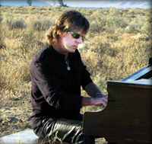
Born November 2, 1944 in Todmorden, Lancashire, England, Keith Emerson soon became a piano sensation in his hometown of Worthing, Sussex by the time he was fourteen years old. In his late teens, he moved to London and became influenced by jazz artists and classical composers.

He formed the band The Nice and was one of the first to use a Moog Synthesizer, an instrument he made famous on the iconic song written by Greg Lake and performed by Emerson Lake and Palmer – their hit Lucky Man.

In 1970, "The Nice" broke up and Emerson formed the legendary group, "Emerson, Lake & Palmer" (ELP) with bassist/vocalist Greg Lake and drummer Carl Palmer. They achieved instant fame with their debut at the Isle Of Wight Festival in 1970... Their first single, entitled "Lucky Man", from their debut album, "Emerson, Lake & Palmer", ended with a startling new sound, the lead Moog synthesizer solo. This sound took the world by storm, and the band was on its way. ELP released six platinum albums between 1970 and 1977, including "E, L & P," "Tarkus," "Trilogy", the cryptically entitled "Brain Salad Surgery", "Welcome Back My Friends To The Show That Never Ends" and "Works Vol. 1". They headlined the massive 1974 festival California Jam playing to an audience of over 500,000.

Emerson, Lake and Palmer disbanded several times so its members could pursue solo careers; with the late Cozy Powell, Emerson and Lake joined together again, and each time the band have re-united on stage, fans have come by the thousands to see them.

Emerson has continued on a successful solo career, releasing film tracks and a series of solo albums as well as making guest appearances around the world with artists of all genres.

……………………………………………..

Greg Lake
Vocalist, musician and producer, Greg Lake is one of the most prominent and popular musicians in the world and has often been described as having the voice of a generation.
He first won worldwide acclaim as lead vocalist, bass guitarist and producer when together with Robert Fripp he formed King Crimson. Their first album, In Court of the Crimson King, co-produced by Greg, featured the iconic song "21st Century Schizoid Man." King Crimson pioneered progressive rock and paved the way for famous bands that followed, including Yes and Genesis all the way through to bands such as The Red Hot Chili Peppers and countless others.
Greg met fellow legend Keith Emerson during a North American tour where Emerson’s band, The Nice shared the bill with King Crimson. The two shared common bonds: diverse musical influences and a desire to reinterpret classical works while creating new classics in a new musical genre. They also shared a perfectionist perspective which made them challenge each other and challenge the success and recognition they had previously achieved.
After returning to England Greg and Keith were introduced to Atomic Rooster drummer Carl Palmer, by Robert Stigwood, and very soon thereafter they formed Emerson Lake and Palmer.
The three created a unique live theatrical performance which stretched the imagination and enthralled audiences. One of their very first exceptional performances together was at the historic Isle of Wight Festival. That special concert propelled them on their path to become one of the world’s first “super groups.”
The 1971 debut album, Emerson Lake and Palmer went platinum. It was produced by Lake and featured a song Greg had written while still in school: “Lucky Man.” “Lucky Man,” performed on acoustic guitar, would become an iconic song for the band and a popular classic on radio.
Lake’s remarkable voice also powered ELP’s more electric pieces such as Karn Evil #9, one of the world’s most beloved songs. The opening line “Welcome Back My Friends to the Show that Never ends…” is an international favourite, globally used as a television theme
to date Emerson Lake and Palmer has sold over 48 million records. Lake produced Tarkus, Pictures at an Exhibition, Trilogy, Brain Salad Surgery, Works Vol. 1 and 2, and two different live albums. All went platinum and featured a series of hit singles , most written and all sung by Greg, who credits their success to his constant search for perfection and his heart, two qualities he believes he shares with ELP keyboard luminary Keith Emerson.
Greg Lake has formed partnerships on stage, and off, in performances, writing, recording, and productions with musicians whose brilliance matches his own. Solo tours and recordings have been extremely successful as he continues to recreate hits, add to his vast repertoire and raise the bar for others in the industry.

Greg is extremely pleased at the opportunity to reunite with his old friend and writing and performing partner Keith Emerson in this unique way, giving American fans a unique and unusual view of the two and their music just prior to the heralded reunion of Emerson, Lake and Palmer which will headline the prestigious UK High Voltage festival with the same breathtaking theatrics and extraordinary playing that drew fans immediately to the band.

